Clothing in Zimbabwe
Daily Clothing
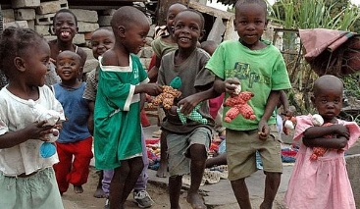
Everyday clothing in Zimbabwe is quite similar to our summer clothing in Hong Kong. Women wear skirts or dresses and often wrap a cloth around their hair. Men wear pants and shirts. Boys wear shorts or pants and T-shirts, and girls wear simple dresses call shifts. Children may wear uniforms when they attend some schools. Most of the people in Zimbabwe do not wear the traditional Zimbabwe Clothing any more. The modern style clothes have long been adopted by the Zimbabweans. Youth dons casual T-shirts, jeans, and shorts. Most clothes are made from a light fabric called cotton which is grown in Zimbabwe.

Traditional Clothing For Women (Ndebele)
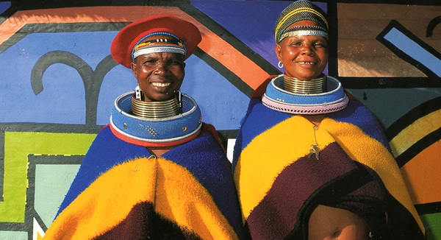
Their traditional dress is colourful and bright and is decorated with a lot of beautiful bead work. A woman’s traditional dress shows her age and status in the community. A married woman traditionally wears a blanket over her shoulders with a lot of thick beaded hoops of twisted grass, called “isigolwani” around her neck and legs. She also wears copper and brass rings or “Idzilla” around her arms, neck and legs. The blanket or “nguba” is usually one with stripes of green, red, blue, yellow and brown.
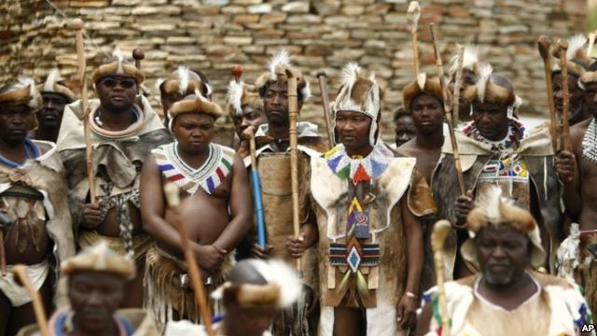
Traditional Clothing for Men (Ndebele)
The main part of the male attires of Zimbabwe is the breastplate, which is also known as Iporiyana. It is worn around the neck. Men also wear animal skin head bands and ankle bands. To keep warm, they wear an animal skin ‘“karos” around their shoulders. Animal skin traditionally played an important role in men’s dress because each Ndebele group is associated with a different animal.

**Traditional clothing is rare to see, except in isolated villages and during traditional celebrations**

